CYBER SECURITY NETWORKWALKS INTERNSHIP
NETWORKWALKS-B083-WK3-PM-PASSWORD-CRACKING

Submitted by
Muhammad Arslan Nadeem

Date
September 9th, 2026

1-Liability Disclaimer:
I have performed these activities only on systems and devices where I had secured written permission or that I own myself. All materials are for educational and research purposes only. Do not use anything from here to break the law. The instructor, the authors and NetworkWalks are not responsible for what you do with this knowledge. Every action you take is your own responsibility. Misuse can lead to criminal charges, heavy fines, loss of your job and a permanent record. In most countries unauthorised access is a crime even when nothing is damaged.

2-Introduction:
This report covers password cracking activities performed during Week 3 of my Cyber security & Ethical Hacking internship at NetworkWalks. The target was a password-protected PDF file (My Locked PDF1.pdf) provided by the instructor for authorized educational testing.
Two essential modules were completed as part of this week's project:
- W3-PM1: Password cracking using John the Ripper (JTR) — a command-line tool available pre-installed in Kali Linux.
- W3-PM2: Password cracking using two browser-based tools by NetworkWalks — the Hash Calculator and the Password Cracker.
The purpose of this lab was to understand how password hashing works, how dictionary attacks function, and why strong passwords are essential for protecting sensitive data. All activities were performed on Kali Linux (running inside VMware) and a Windows PC with a web browser.

3-Tools Used:
The table below lists each tool used in this report and its purpose.

Tools | Purpose
Kali Linux | Operating System for JTR tools
John The Ripper (JTR) | Command line password cracking tool
Pdf2john | Extracts crack able hashes from pdf files
Rockyou.txt | Wordlist for dictionary attacks
NetworkWalks Hash Calculator | Browser based hash extractor
NetworkWalks Password Cracker | Browser based dictionary attacker

4-Activities Performed:
4.1 Password Cracking with JTR:
For this module, I used John the Ripper (JTR) on Kali Linux to crack the password of the locked PDF file provided by the instructor. Kali Linux comes with John and pdf2john pre-installed, so no additional installation was required.
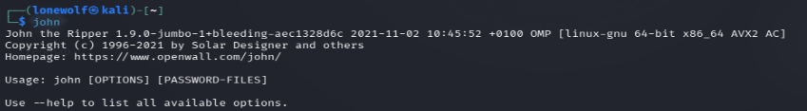
After checking the version of john, I extracted crack able hashes from a provided file “My Locked PDF1.pdf”. The command to execute this task is:
pdf2john "My Locked PDF1.pdf" > pdf_hash.txt

The output of above command is:
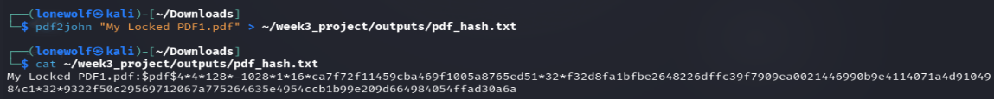

The pdf2john script successfully extracted the crack able hash from the PDF. The hash starts with $pdf$4*4*128* which indicates it is a PDF hash using MD5 with AES-128 encryption. Revision 4, Version 4, 128-bit key length.

After getting the hash, I will use JTR again to crack this hash to get the password of this file. The command that will do this is:
john --wordlist=/usr/share/wordlists/rockyou.txt pdf_hash.txt

The output of the above command will gives:
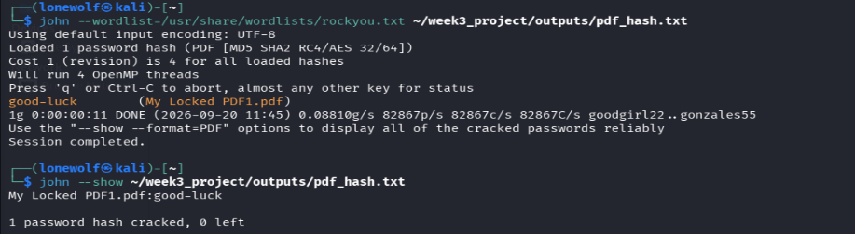

John successfully cracked the password. The password was "good-luck" — a very common weak password that appears early in the rockyou.txt wordlist. This demonstrates how quickly weak passwords fall to dictionary attacks.

Now that I have the password, I will use it and so if JTR cracked the right password or not.
I opened the PDF file and entered the password "good-luck" when prompted.
The PDF opened successfully, displaying the congratulations message:
"Congratulations! You have captured your 1st flag. Let's continue this amazing journey of Cyber Security with incredible team of instructors at NetworkWalks."
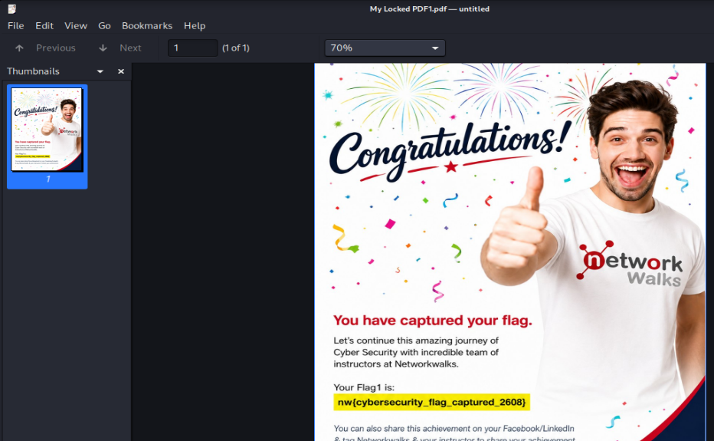

4.1 Password Cracking with NetworkWalks Tools:
For this module, I used two browser-based tools created by NetworkWalks. No installation was required, both tools run directly in a web browser.
I opened Firefox and navigated to:
https://networkwalks.com/hash-calculator/
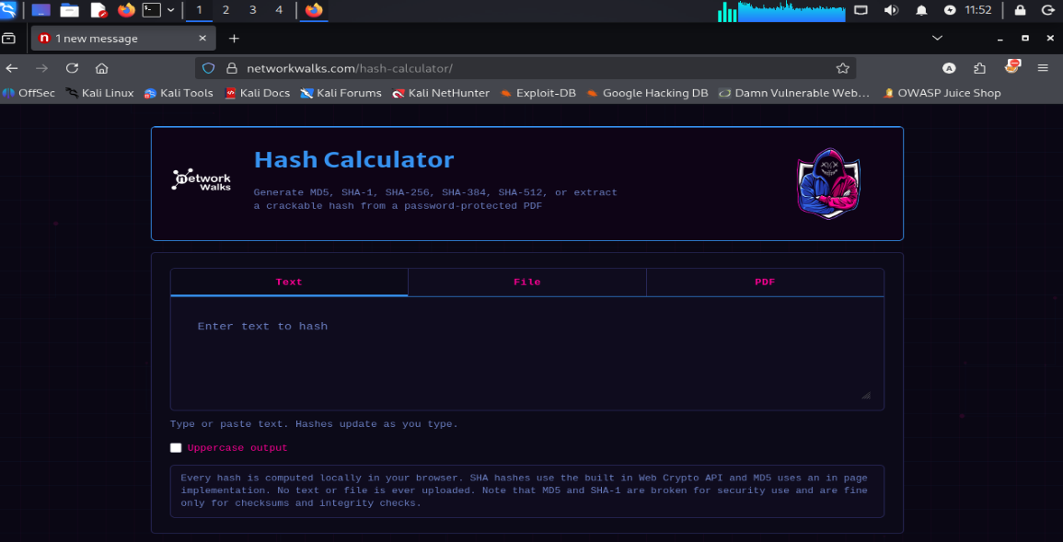
I clicked the "PDF" tab, then clicked "Click to choose a PDF, or drag one here" and selected My Locked PDF1.pdf from my Downloads folder.
The tool successfully extracted the hash from the PDF:
$pdf$4*4*128*-1060*1*16*5d1a5c... (long hash value)
The tool also showed: "This PDF is encrypted. A crack able hash has been extracted below (pdf2john / hashcat compatible format)."
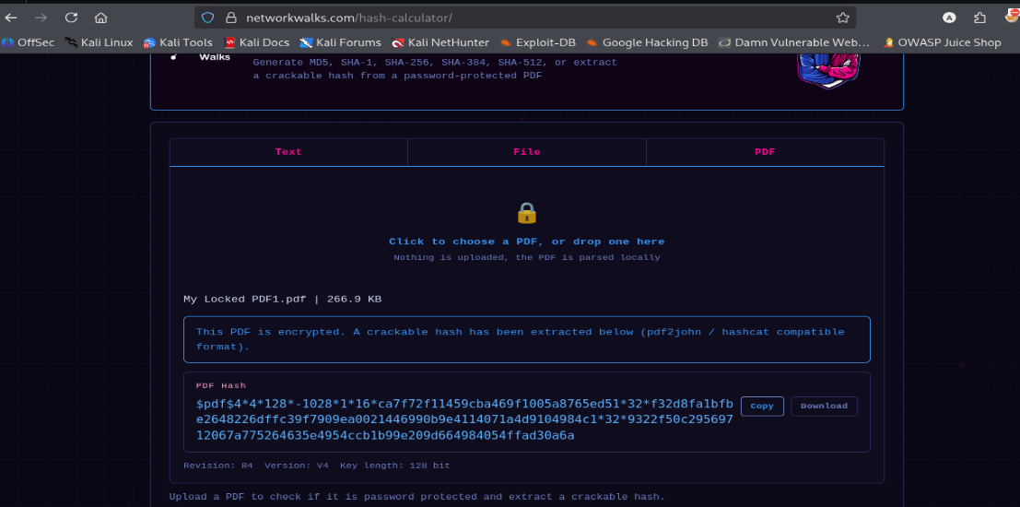
After copying the hash from hash calculator, I opened a new tab and navigated to:
https://networkwalks.com/password-cracker/
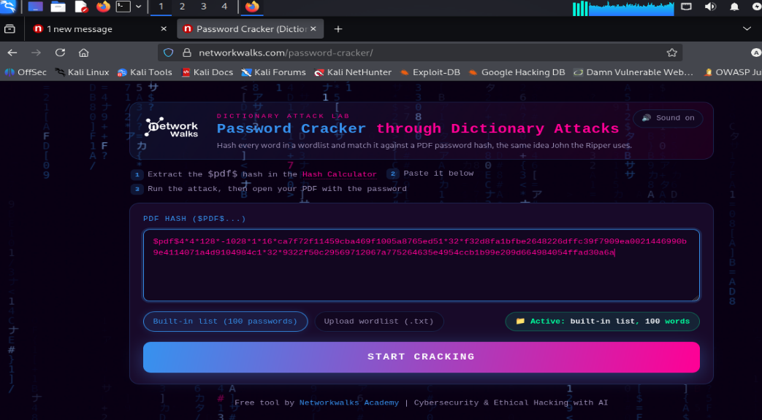
I pasted the hash into the "PDF HASH ($pdf$ ...)" text box, selected the dictionary from wordlists folder and clicked "START CRACKING".
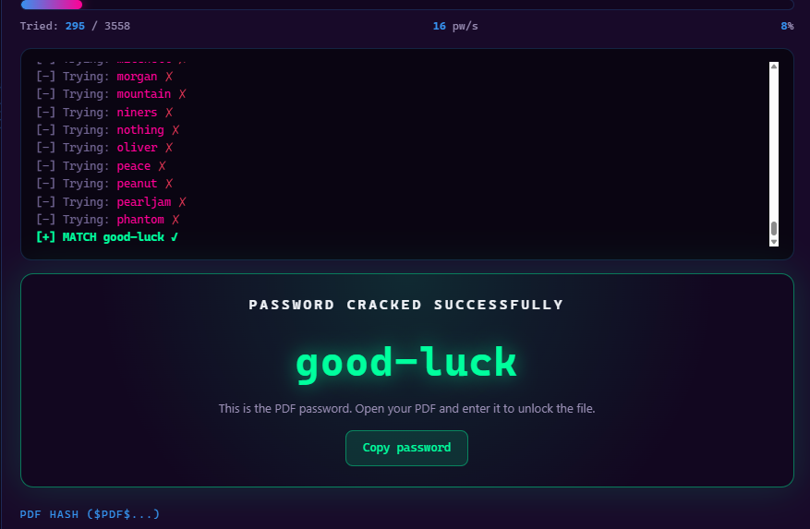
The tool ran through the wordlist and displayed:
PASSWORD CRACKED SUCCESSFULLY
good-luck
This is the PDF password. Open your PDF and enter it to unlock the file.

5-Risk Analysis:
Based on the password cracking activities performed, I identified the following risks associated with weak password protection:
Risk | Impact | Level
Weak Password used on pdf | Anyone can access confidential files | High
Password appears in common wordlist | Dictionary attacks succeed instantly | High
Simple pattern | Passwords predictable by attackers | Medium
No account lockout mechanism | Unlimited brute-force attempts possible | Medium
Offline cracking possible | No alert triggered during cracking | Medium
The risks above are observations from the password cracking exercises, not confirmed vulnerabilities in any production system. The file used was provided specifically for this lab, and no real-world systems were targeted.

6-Recommandations:
Based on the observations from these activities, I recommend the following security improvements:
- Use strong passwords
- Enable 2 factor authentication
- Encrypt sensitive files
- Never share passwords via insecure channels

